(question 3)

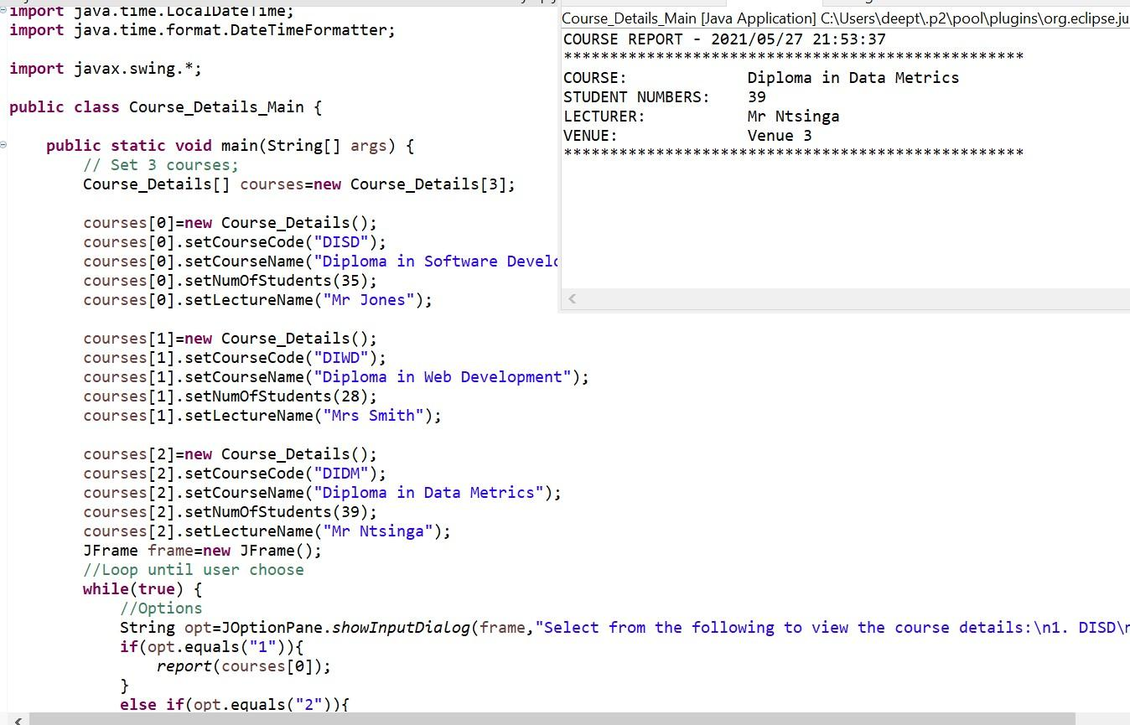**Course_Details.java**

public class Course_Details {  
   //Instance variables  
       private String courseCode,courseName,lectureName;  
       private int numOfStudents;  
        
       //Getters and setters  
       public String getCourseCode() {  
           return courseCode;  
       }  
       public void setCourseCode(String courseCode) {  
           this.courseCode = courseCode;  
       }  
       public String getCourseName() {  
           return courseName;  
       }  
       public void setCourseName(String courseName) {  
           this.courseName = courseName;  
       }  
       public String getLectureName() {  
           return lectureName;  
       }  
       public void setLectureName(String lectureName) {  
           this.lectureName = lectureName;  
       }  
       public int getNumOfStudents() {  
           return numOfStudents;  
       }  
       public void setNumOfStudents(int numOfStudents) {  
           this.numOfStudents = numOfStudents;  
       }  
       //Method assign venue  
       public int AssignVenue() {  
       return new Random().nextInt(3)+1;  
       }

}

**Course_Details_Main.java**

import java.time.LocalDateTime;  
import java.time.format.DateTimeFormatter;

import javax.swing.*;

public class Course_Details_Main {

   public static void main(String[] args) {  
       // Set 3 courses;  
       Course_Details[] courses=new Course_Details[3];  
        
       courses[0]=new Course_Details();  
       courses[0].setCourseCode("DISD");  
       courses[0].setCourseName("Diploma in Software Development");  
       courses[0].setNumOfStudents(35);  
       courses[0].setLectureName("Mr Jones");  
        
       courses[1]=new Course_Details();  
       courses[1].setCourseCode("DIWD");  
       courses[1].setCourseName("Diploma in Web Development");  
       courses[1].setNumOfStudents(28);  
       courses[1].setLectureName("Mrs Smith");  
        
       courses[2]=new Course_Details();  
       courses[2].setCourseCode("DIDM");  
       courses[2].setCourseName("Diploma in Data Metrics");  
       courses[2].setNumOfStudents(39);  
       courses[2].setLectureName("Mr Ntsinga");  
       JFrame frame=new JFrame();  
       //Loop until user choose  
       while(true) {  
           //Options  
           String opt=JOptionPane.showInputDialog(frame,"Select from the following to view the course details:\n1. DISD\n2. DIWD\n3. DIDM");  
           if(opt.equals("1")){  
               report(courses[0]);  
           }  
           else if(opt.equals("2")){  
               report(courses[1]);  
           }  
           else if(opt.equals("3")){  
               report(courses[2]);  
           }  
           //Exit box  
           opt=JOptionPane.showInputDialog(frame,"Would you like to exit the application?Enter(y)to use exit and any other key to continue.");  
           if(opt.equals("y")) {  
               break;  
           }  
       }  
   }  
   //Method generate a course details  
   static void report(Course_Details cd) {  
       DateTimeFormatter dtf = DateTimeFormatter.ofPattern("yyyy/MM/dd HH:mm:ss");  
       LocalDateTime now = LocalDateTime.now();  
       System.out.println("COURSE REPORT - "+dtf.format(now));  
       System.out.println("**************************************************");  
       System.out.printf("%-20s%s\n","COURSE:",cd.getCourseName());  
       System.out.printf("%-20s%s\n","STUDENT NUMBERS:",cd.getNumOfStudents());  
       System.out.printf("%-20s%s\n","LECTURER:",cd.getLectureName());  
       System.out.printf("%-20s%s\n","VENUE:","Venue "+cd.AssignVenue());  
       System.out.println("**************************************************");  
   }  
}

**Output**

COURSE REPORT - 2021/05/27 21:53:37  
**************************************************  
COURSE: Diploma in Data Metrics  
STUDENT NUMBERS: 39  
LECTURER: Mr Ntsinga  
VENUE: Venue 3  
**************************************************

(q3)

mport java.text.SimpleDateFormat;

import java.util.Date;

import java.util.Random;

public class Course_Details {

private String courseCode;

private String courseName;

private int studentNumbers;

private String lecturer;

public String getCourseCode() {

return courseCode;

}

public void setCourseCode(String courseCode) {

this.courseCode = courseCode;

}

public String getCourseName() {

return courseName;

}

public void setCourseName(String courseName) {

this.courseName = courseName;

}

public int getStudentNumbers() {

return studentNumbers;

}

public void setStudentNumbers(int studentNumbers) {

this.studentNumbers = studentNumbers;

}

public String getLecturer() {

return lecturer;

}

public void setLecturer(String lecturer) {

this.lecturer = lecturer;

}

public String assignVenue() {

Random random = new Random();

return "Venue " + (random.nextInt(3) + 1); // generates random integer from (0 to 2) + 1, so 1 to 3

}

public static void printReport(Course_Details courseDetails) {

SimpleDateFormat formatter = new SimpleDateFormat("dd/MM/yyyy HH:mm:ss");

Date date = new Date();

System.out.println("COURSE REPORT - " + formatter.format(date));

System.out.println("********************************************************");

System.out.println("COURSE:\t\t\t" + courseDetails.getCourseName());

System.out.println("STUDENT NUMBERS:\t" + courseDetails.getStudentNumbers());

System.out.println("LECTURER:\t\t" + courseDetails.getLecturer());

System.out.println("VENUE:\t\t\t" + courseDetails.assignVenue());

System.out.println("********************************************************");

}

}

(question 3)

public class Course_Details {

// instance variables

private String courseCode, courseName;

private int studentNumbers;

private String lecturer;

/**

* Parameterized constructor: creates an instance of Course_Details with the values passed in as parameters.

* @param courseCode the course code

* @param courseName the name of the course

* @param studentNumbers the number of students allowed for the course

* @param lecturer the name of the lecturer

* */

public Course_Details(String courseCode, String courseName, int studentNumbers, String lecturer) {

this.courseCode = courseCode;

this.courseName = courseName;

this.studentNumbers = studentNumbers;

this.lecturer = lecturer;

}

/* ACCESSOR/GETTER METHODS FOR ALL ITS ATTRIBUTES */

/* This method returns the code for the course */

public String getCourseCode() {

return courseCode;

}

/* This method returns the name for the course */

public String getCourseName() {

return courseName;

}

/* This method returns the number of students allowed for the course */

public int getStudentNumbers() {

return studentNumbers;

}

/* This method returns the name of the lecturer for the course */

public String getLecturer() {

return lecturer;

}

/* MUTATOR/SETTER METHODS FOR ALL ITS ATTRIBUTES EXCEPT FOR THE ATTRIBUTE 'courseCode' */

/**

* This method sets a new value for the courseName attribute.

* @param courseName the new course name

* */

public void setCourseName(String courseName) {

this.courseName = courseName;

}

/**

* This method sets a new value for the studentNumbers attribute.

* @param studentNumbers the new number of students for the course

* */

public void setStudentNumbers(int studentNumbers) {

this.studentNumbers = studentNumbers;

}

/**

* This method sets a new value for the lecturer attribute.

* @param lecturer the new lecturer for the course

* */

public void setLecturer(String lecturer) {

this.lecturer = lecturer;

}

/**

* This method randomly generates a Venue/Class for the course, and the venue should be an integer between 1 & 3.

* */

public int AssignVenue() {

return ((int) ((Math.random() * (3 - 1)) + 1));

}

/* This method returns a String, the description of the Course_Details object. */

@Override

public String toString() {

return("Course Name: " + courseName + ", Student Numbers: " + studentNumbers + ", Lecturer: " + lecturer);

}

}

**CODE SCREENSHOTS :**

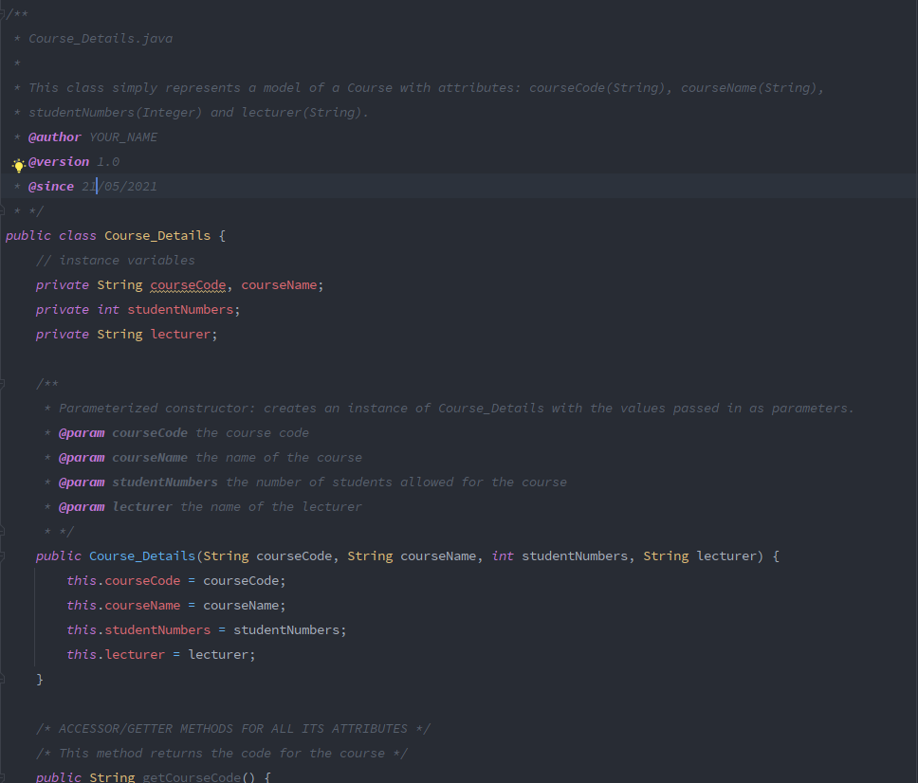

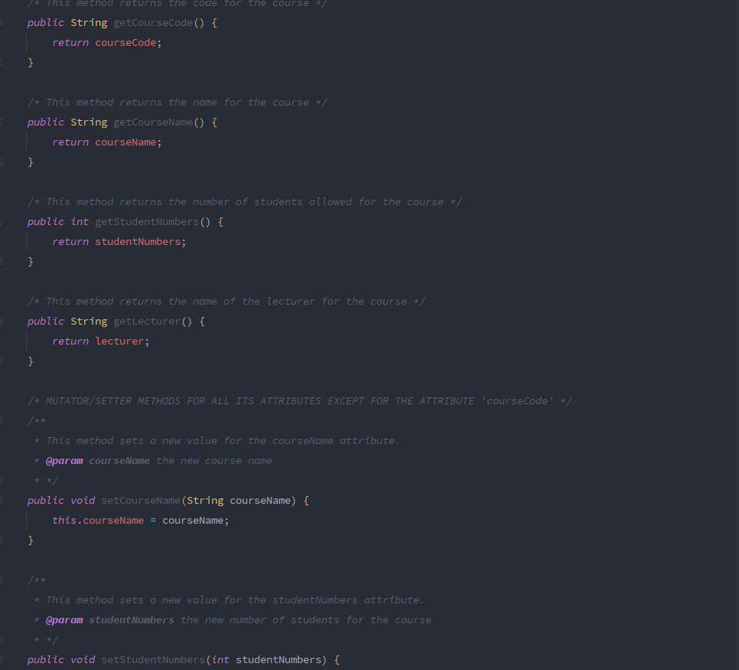

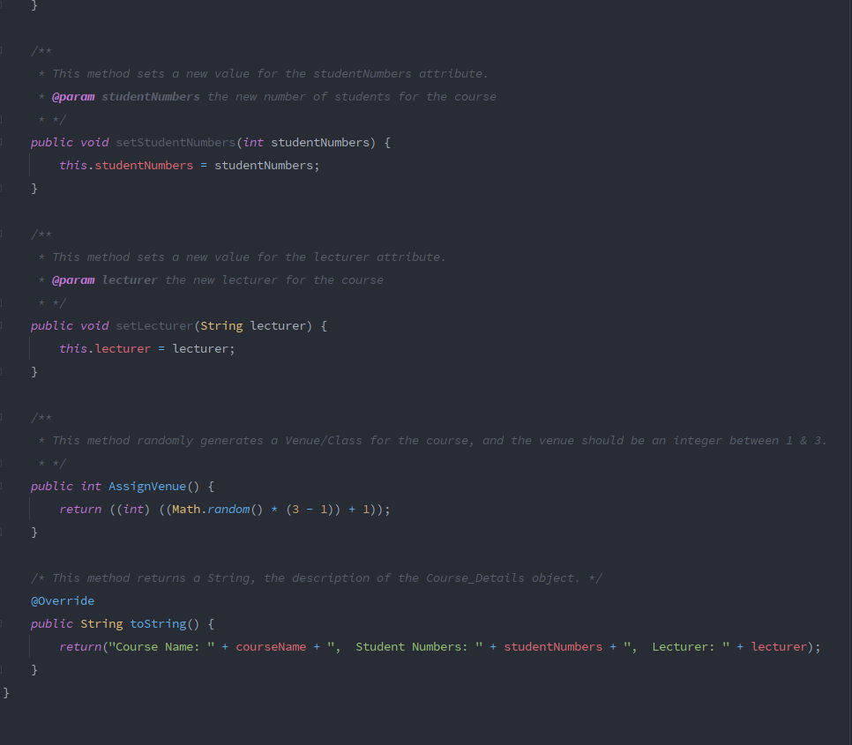

**CourseDetailsDemo.java (Main class)**

import javax.swing.*;

/**

* CourseDetailsDemo.java

*

* This class contains the main method which prompts user for a course code and displays the details of the course.

* @author YOUR_NAME

* @version 1.0

* @since 21/05/2021

* */

public class CourseDetailsDemo {

/**

* This is the main method which is responsible for running the program.

* @param args command line arguments

* */

public static void main(String[] args) {

// we declare an array of Course_Details objects of size 3 and populate the array

Course_Details[] courses = new Course_Details[3];

courses[0] = new Course_Details("DISD", "Diploma in Software Development", 35, "Mr. Jones");

courses[1] = new Course_Details("DIWD", "Diploma in Web Development", 28, "Mr. Smith");

courses[2] = new Course_Details("DIDM", "Diploma in Data Metrics", 39, "Mr. Ntsinga");

// now prompt user with the dialog box containing the menu of Courses

int choice = Integer.parseInt(JOptionPane.showInputDialog(null,

"Select from the following to view the course details:\n1) DISD\n2) DIWD\n3) DIDM", "Input", JOptionPane.INFORMATION_MESSAGE));

// continue prompting until valid integer choice is entered

while(choice < 1 || choice > 3) {

JOptionPane.showMessageDialog(null, "Invalid choice: " + choice + " !");

choice = Integer.parseInt(JOptionPane.showInputDialog(null,

"Select from the following to view the course details:\n1) DISD\n2) DIWD\n3) DIDM", "Input", JOptionPane.INFORMATION_MESSAGE));

}

// now a valid input has been provided, decrement the index by 1 for the array

choice--;

// get the Course_Details object from the array 'courses' by the choice

Course_Details course = courses[choice];

// now call the 'AssignValue()' method of the object above to get the venue

int venue = course.AssignVenue();

// now call the method 'printCourseDetails()' with the 'course' object and the 'venue' as parameters

printCourseDetails(course, venue);

}

/**

* This method takes in two parameters: an object of Course_Details and an integer which is the venue/class for the

* course and prints the course report.

* @param course the object of Course_Details

* @param venue the venue/class for the course

* */

public static void printCourseDetails(Course_Details course, int venue) {

// we print the 'course' using the toString() method of the Course_Details class and then the venue

JOptionPane.showMessageDialog(null, "COURSE DETAILS:\n" +

"--------------------------\n"

+ course + "\nVenue: " + venue, "Print Course Details", JOptionPane.INFORMATION_MESSAGE);

}

}

**CODE SCREENSHOTS :**

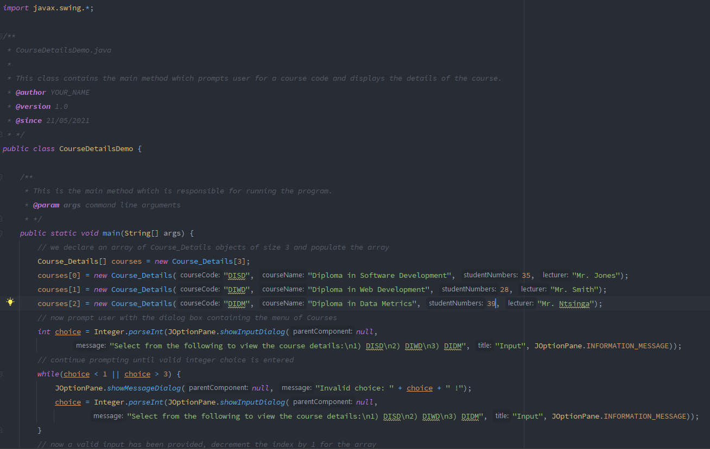

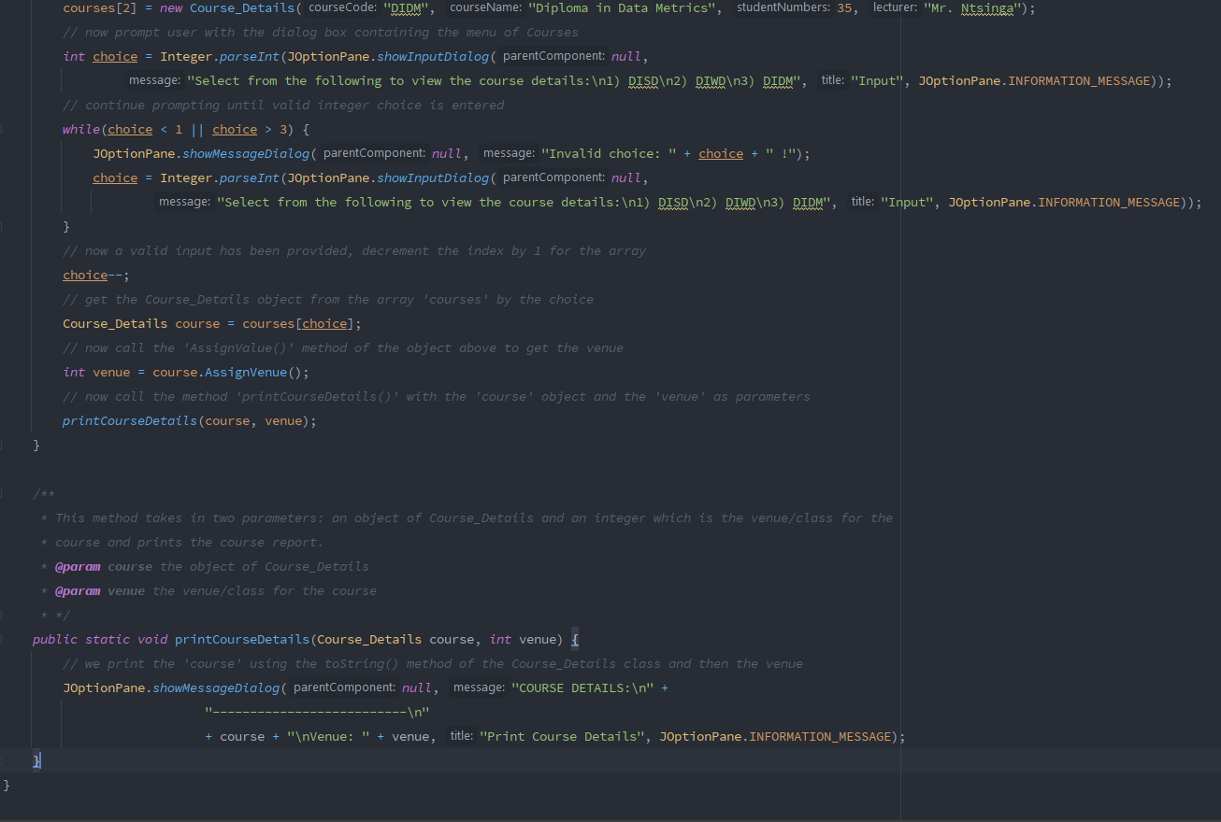

**\*\*\*\*\*\*\*\*\*\*\*\*\*\*\*\*\*\*\*\*\*\*\*\*\*\*\*\*\*\*\*\*\*\*\*\*\*\*\*\*\*\*\*\*\*\*\*\*\*\*\*\*\*\*\*\*\*\*\*\*\*\*\*\*\*\*\*\*\*\*\*\*\*\*\*\*\*\*\*\*\*\*\*\*\*\*\*\*\*\*\*\*\*\*\*\*\*\*\*\*\*\*\*\*\*\*\*\*\*\*\*\*\*\*\*\*\*\*\*\*\*\*\*\*\*\*\*\*\*\*\***

**OUTPUT :**

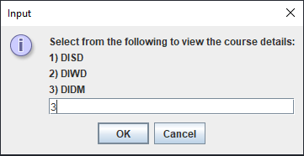

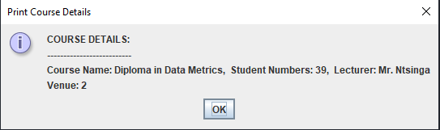

package maincourse_details;

import java.util.Random;  
import javax.swing.JOptionPane;

public class MainCourse_Details {  
public static void main(String args[]) {

// create a course details named disd  
MainCourse_Details disd = new MainCourse_Details("DISD");  
// set course name  
disd.setCourseName("Diploma in Software Development");  
// set student number  
disd.setStudentNumbers(35);  
// set lecturer name  
disd.setLecturerName("Mr Jones");

// create a course details named diwd  
MainCourse_Details diwd = new MainCourse_Details("DIWD");  
diwd.setCourseName("Diploma in Web Development");  
diwd.setStudentNumbers(28);  
diwd.setLecturerName("Mrs Smith");

// create a course details named didm  
MainCourse_Details didm = new MainCourse_Details("DIDM");  
// set course name  
didm.setCourseName("Diploma in Data Matrics");  
// set student number  
didm.setStudentNumbers(39);  
// set lecturer name  
didm.setLecturerName("Mr Ntsinga");

// do while loop to see the all courses till user not entered another number  
int input = 0;  
do {  
input = Integer.parseInt(JOptionPane.showInputDialog(  
"Select from the following to view the course details:\n" + "1) DISD\n" + "2) DIWD\n" + "3) DIDM"));

if (input == 1) {

JOptionPane.showMessageDialog(null, disd.toString());  
} else if (input == 2) {

JOptionPane.showMessageDialog(null, diwd.toString());  
} else if (input == 3) {

JOptionPane.showMessageDialog(null, didm.toString());  
}  
} while (input <= 3 && input >= 1);

// Assign the class  
int classNo = MainCourse_Details.assignVanue();

if (classNo == 1) {

JOptionPane.showMessageDialog(null, "Following class is Scheduled: \n" + disd.toString());  
} else if (classNo == 2) {

JOptionPane.showMessageDialog(null, "Following class is Scheduled: \n" + diwd.toString());  
} else {

JOptionPane.showMessageDialog(null, "Following class is Scheduled: \n" + didm.toString());  
}  
}

private String courseCode;

/** The course name. */  
private String courseName;

/** The student numbers. */  
private int studentNumbers;

/** The lecturer name. */  
private String lecturerName;

/**  
* Instantiates a new course details.  
*/  
public MainCourse_Details() {  
this.courseCode = "";  
this.courseName = "";  
this.studentNumbers = 0;  
this.lecturerName = "";  
}

/**  
* Instantiates a new course details.  
*  
* @param courseCode the course code  
*/  
public MainCourse_Details(String courseCode) {  
this.courseCode = courseCode;  
this.courseName = "";  
this.studentNumbers = 0;  
this.lecturerName = "";  
}

/**  
* Gets the course name.  
*  
* @return the course name  
*/  
public String getCourseName() {  
return courseName;  
}

/**  
* Sets the course name.  
*  
* @param courseName the new course name  
*/  
public void setCourseName(String courseName) {  
this.courseName = courseName;  
}

/**  
* Gets the student numbers.  
*  
* @return the student numbers  
*/  
public int getStudentNumbers() {  
return studentNumbers;  
}

/**  
* Sets the student numbers.  
*  
* @param studentNumbers the new student numbers  
*/  
public void setStudentNumbers(int studentNumbers) {  
this.studentNumbers = studentNumbers;  
}

/**  
* Gets the lecturer name.  
*  
* @return the lecturer name  
*/  
public String getLecturerName() {  
return lecturerName;  
}

/**  
* Sets the lecturer name.  
*  
* @param lecturerName the new lecturer name  
*/  
public void setLecturerName(String lecturerName) {  
this.lecturerName = lecturerName;  
}

/**  
* Gets the course code.  
*  
* @return the course code  
*/  
public String getCourseCode() {  
return courseCode;  
}

/**  
* Assign vanue.  
*  
* @return the int  
*/  
public static int assignVanue() {

return new Random().nextInt(3) + 1;

}  
    
@Override

public String toString() {  
return("Course Details \nCourse Code: " + courseCode + "\nCourse Name: " + courseName + "\nStudent Numbers: "  
+ studentNumbers + "\nLecturer Name: " + lecturerName);  
}

class Printing extends MainCourse_Details  
{  
void PrintDetails()  
{  
    
    
System.out.println("Application complete");  
System.exit(0);  
}  
}  
}

(q3)

import java.util.Random;

public class Course_Details {

//Instance variables

private String courseCode,courseName,lectureName;

private int numOfStudents;

//Getters and setters

public String getCourseCode() {

return courseCode;

}

public void setCourseCode(String courseCode) {

this.courseCode = courseCode;

}

public String getCourseName() {

return courseName;

}

public void setCourseName(String courseName) {

this.courseName = courseName;

}

public String getLectureName() {

return lectureName;

}

public void setLectureName(String lectureName) {

this.lectureName = lectureName;

}

public int getNumOfStudents() {

return numOfStudents;

}

public void setNumOfStudents(int numOfStudents) {

this.numOfStudents = numOfStudents;

}

//Method assign venue

public int AssignVenue() {

return new Random().nextInt(3)+1;

}

}

* **Code(main.java):**

import java.time.LocalDateTime;

import java.time.format.DateTimeFormatter;

import javax.swing.*;

public class Course_Details_Main {

public static void main(String[] args) {

// Set 3 courses;

Course_Details[] courses=new Course_Details[3];

courses[0]=new Course_Details();

courses[0].setCourseCode("DISD");

courses[0].setCourseName("Diploma in Software Development");

courses[0].setNumOfStudents(35);

courses[0].setLectureName("Mr Jones");

courses[1]=new Course_Details();

courses[1].setCourseCode("DIWD");

courses[1].setCourseName("Diploma in Web Development");

courses[1].setNumOfStudents(28);

courses[1].setLectureName("Mrs Smith");

courses[2]=new Course_Details();

courses[2].setCourseCode("DIDM");

courses[2].setCourseName("Diploma in Data Metrics");

courses[2].setNumOfStudents(39);

courses[2].setLectureName("Mr Ntsinga");

JFrame frame=new JFrame();

//Loop until user choose

while(true) {

//Options

String opt=JOptionPane.showInputDialog(frame,"Select from the following to view the course details:\n1. DISD\n2. DIWD\n3. DIDM");

if(opt.equals("1")){

report(courses[0]);

}

else if(opt.equals("2")){

report(courses[1]);

}

else if(opt.equals("3")){

report(courses[2]);

}

//Exit box

opt=JOptionPane.showInputDialog(frame,"Would you like to exit the application?Enter(y)to use exit and any other key to continue.");

if(opt.equals("y")) {

break;

}

}

}

//Method generate a course details

static void report(Course_Details cd) {

DateTimeFormatter dtf = DateTimeFormatter.ofPattern("yyyy/MM/dd HH:mm:ss");

LocalDateTime now = LocalDateTime.now();

System.out.println("COURSE REPORT - "+dtf.format(now));

System.out.println("**************************************************");

System.out.printf("%-20s%s\n","COURSE:",cd.getCourseName());

System.out.printf("%-20s%s\n","STUDENT NUMBERS:",cd.getNumOfStudents());

System.out.printf("%-20s%s\n","LECTURER:",cd.getLectureName());

System.out.printf("%-20s%s\n","VENUE:","Venue "+cd.AssignVenue());

System.out.println("**************************************************");

}

}

* **Output:**

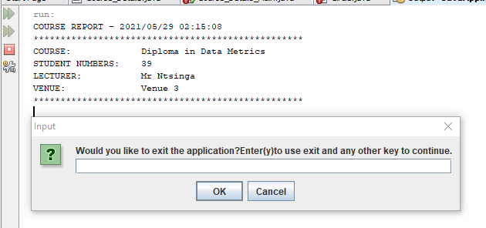

(Q1)

import java.io.BufferedReader;

import java.io.IOException;

import java.io.InputStreamReader;

import java.text.DecimalFormat;

import java.util.Scanner;

class CustomerPurchase

{

int customernumber;

String firstname;

String surname;

String product;

double productprice;

int quantity;

public CustomerPurchase() {

this.customernumber=customernumber;

this.firstname=firstname;

this.surname=surname;

this.product=product;

this.productprice=productprice;

this.quantity=quantity;

}

public int getCustomernumber() {

return customernumber;

}

public void setCustomernumber(int customernumber) {

this.customernumber = customernumber;

}

public String getFirstname() {

return firstname;

}

public void setFirstname(String firstname) {

this.firstname = firstname;

}

public String getSurname() {

return surname;

}

public void setSurname(String surname) {

this.surname = surname;

}

public String getProduct() {

return product;

}

public void setProduct(String product) {

this.product = product;

}

public double getProductprice() {

return productprice;

}

public void setProductprice(double productprice) {

this.productprice = productprice;

}

public int getQuantity() {

return quantity;

}

public void setQuantity(int quantity) {

this.quantity = quantity;

}

}

class Printing extends CustomerPurchase

{

void PrintDetails()

{

System.out.println("CUSTOMER INVOICE");

System.out.println("****************************");

System.out.println("CUSTOMER NUMBER: "+getCustomernumber());

System.out.println("CUSTOMER FIRST NAME: "+getFirstname());

System.out.println("CUSTOMER SURNAME: "+getSurname());

System.out.println("PRODUCT PRICE: R "+getProductprice());

System.out.println("PRODUCT QUANTITY: "+getQuantity());

System.out.println("****************************");

}

void Customerpurchasereport()

{

DecimalFormat d1=new DecimalFormat("#.00");

double total=(getProductprice()+getProductprice()*0.15)-(getProductprice()*0.1+getProductprice()*0.085);

System.out.println("CUSTOMER PURCHASE REPORT");

System.out.println("****************************");

System.out.println("PRODUCT PRICE: R "+d1.format(getProductprice()));

System.out.println("TAX: R "+d1.format(getProductprice()*0.15));

System.out.println("COMMISION: R "+d1.format(getProductprice()*0.085));

System.out.println("DISCOUNT: R "+d1.format(getProductprice()*0.1));

System.out.println("TOTAL: R "+d1.format(total));

System.out.println("****************************");

System.out.println("Application complete");

}

}

public class Main {

public static void main(String[] args) throws NumberFormatException, IOException {

// TODO Auto-generated method stub

int option;

BufferedReader inp = new BufferedReader (new InputStreamReader(System.in));

System.out.print("Enter the customer number >> ");

int n=Integer.parseInt(inp.readLine());

System.out.print("Enter the customer first name >> ");

String firstname=inp.readLine();

System.out.print("Enter the customer Surname >> ");

String surname=inp.readLine();

System.out.print("Enter the product >> ");

String product=inp.readLine();

System.out.print("Enter the product price >> ");

int prdtprc=Integer.parseInt(inp.readLine());

System.out.print("Enter the quantity required >> ");

int quantity=Integer.parseInt(inp.readLine());

Printing p1=new Printing();

p1.setCustomernumber(n);

p1.setFirstname(firstname);

p1.setSurname(surname);

p1.setProduct(product);

p1.setProductprice(prdtprc);

p1.setQuantity(quantity);

p1.PrintDetails();

System.out.println("Would you like to view the product purchase report? Enter(1)");

System.out.println("to view the purchase report or any other key to exit");

option=Integer.parseInt(inp.readLine());

if(option==1)

{

p1.Customerpurchasereport();

}

else

{

System.out.println("Application complete");

System.exit(0);

}

}

}

output:-

Enter the customer number >> 10111

Enter the customer first name >> Alex

Enter the customer Surname >> Jones

Enter the product >> Guitar

Enter the product price >> 5000

Enter the quantity required >> 2

CUSTOMER INVOICE

****************************

CUSTOMER NUMBER: 10111

CUSTOMER FIRST NAME: Alex

CUSTOMER SURNAME: Jones

PRODUCT PRICE: R 5000.0

PRODUCT QUANTITY: 2

****************************

Would you like to view the product purchase report? Enter(1)

to view the purchase report or any other key to exit

1

CUSTOMER PURCHASE REPORT

****************************

PRODUCT PRICE: R 5000.00

TAX: R 750.00

COMMISION: R 425.00

DISCOUNT: R 500.00

TOTAL: R 4825.00

****************************

Application complete

(q1)

CODE:

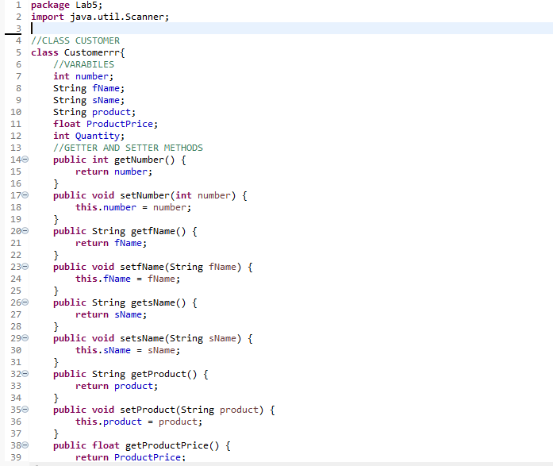

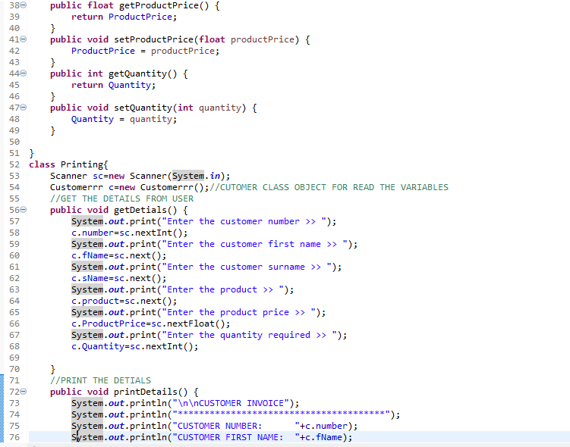

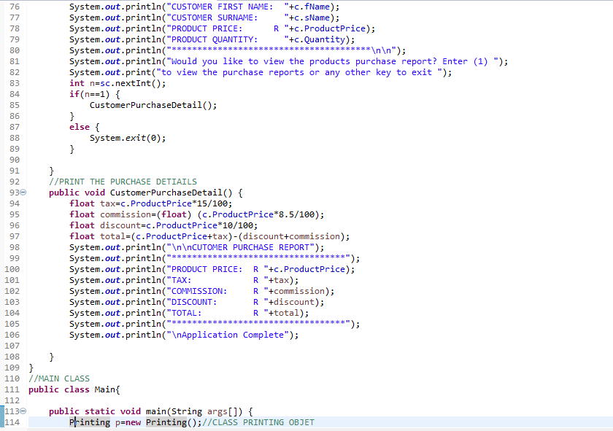

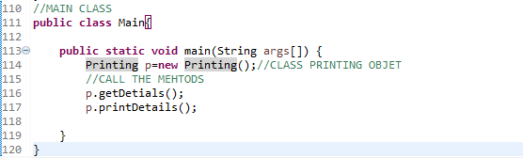

CODE:

package Lab5;  
import java.util.Scanner;

//CLASS CUSTOMER  
class Customerrr{  
   //VARABILES  
   int number;  
   String fName;  
   String sName;  
   String product;  
   float ProductPrice;  
   int Quantity;  
   //GETTER AND SETTER METHODS  
   public int getNumber() {  
       return number;  
   }  
   public void setNumber(int number) {  
       this.number = number;  
   }  
   public String getfName() {  
       return fName;  
   }  
   public void setfName(String fName) {  
       this.fName = fName;  
   }  
   public String getsName() {  
       return sName;  
   }  
   public void setsName(String sName) {  
       this.sName = sName;  
   }  
   public String getProduct() {  
       return product;  
   }  
   public void setProduct(String product) {  
       this.product = product;  
   }  
   public float getProductPrice() {  
       return ProductPrice;  
   }  
   public void setProductPrice(float productPrice) {  
       ProductPrice = productPrice;  
   }  
   public int getQuantity() {  
       return Quantity;  
   }  
   public void setQuantity(int quantity) {  
       Quantity = quantity;  
   }  
    
}  
class Printing{  
   Scanner sc=new Scanner(System.in);  
   Customerrr c=new Customerrr();//CUTOMER CLASS OBJECT FOR READ THE VARIABLES  
   //GET THE DETAILS FROM USER  
   public void getDetials() {  
       System.out.print("Enter the customer number >> ");  
       c.number=sc.nextInt();  
       System.out.print("Enter the customer first name >> ");  
       c.fName=sc.next();  
       System.out.print("Enter the customer surname >> ");  
       c.sName=sc.next();  
       System.out.print("Enter the product >> ");  
       c.product=sc.next();  
       System.out.print("Enter the product price >> ");  
       c.ProductPrice=sc.nextFloat();  
       System.out.print("Enter the quantity required >> ");  
       c.Quantity=sc.nextInt();  
        
   }  
   //PRINT THE DETIALS  
   public void printDetails() {  
       System.out.println("\n\nCUSTOMER INVOICE");  
       System.out.println("***************************************");  
       System.out.println("CUSTOMER NUMBER: "+c.number);  
       System.out.println("CUSTOMER FIRST NAME: "+c.fName);  
       System.out.println("CUSTOMER SURNAME: "+c.sName);  
       System.out.println("PRODUCT PRICE: R "+c.ProductPrice);  
       System.out.println("PRODUCT QUANTITY: "+c.Quantity);  
       System.out.println("***************************************\n\n");  
       System.out.println("Would you like to view the products purchase report? Enter (1) ");  
       System.out.print("to view the purchase reports or any other key to exit ");  
       int n=sc.nextInt();  
       if(n==1) {  
           CustomerPurchaseDetail();  
       }  
       else {  
           System.exit(0);  
       }  
        
   }  
   //PRINT THE PURCHASE DETIAILS  
   public void CustomerPurchaseDetail() {  
       float tax=c.ProductPrice*15/100;  
       float commission=(float) (c.ProductPrice*8.5/100);  
       float discount=c.ProductPrice*10/100;  
       float total=(c.ProductPrice+tax)-(discount+commission);  
       System.out.println("\n\nCUTOMER PURCHASE REPORT");  
       System.out.println("**********************************");  
       System.out.println("PRODUCT PRICE: R "+c.ProductPrice);  
       System.out.println("TAX: R "+tax);  
       System.out.println("COMMISSION: R "+commission);  
       System.out.println("DISCOUNT: R "+discount);  
       System.out.println("TOTAL: R "+total);  
       System.out.println("**********************************");  
       System.out.println("\nApplication Complete");  
        
   }  
}  
//MAIN CLASS  
public class Main{  
    
   public static void main(String args[]) {  
       Printing p=new Printing();//CLASS PRINTING OBJET  
       //CALL THE MEHTODS  
       p.getDetials();  
       p.printDetails();  
        
   }

(q1)